**MOI Airwing Dispatch Process**

1. Daylight hours of operations i.e. 0700-1700
2. National Ambulance resource dispatched
3. Police alerted to incident and responding
4. MOI air wing Auto launch or Cockpit standby zone

**Criteria for Request**

**Probable Mechanism of Injury**

|  |  |
| --- | --- |
| * **Request from National Ambulance Staff** |  |
| * **MVA rollover** |  |
| * **MVA with ejection** |  |
| * **MVA with associated fatality** |  |
| * **MVA pedestrian v vehicle (speed >30kph)** |  |
| * **MVA cyclist v vehicle (speed >30kph)** |  |
| * **MVA entrapment (including under vehicle)** |  |
| * **Significant RTC or multi patient incident in HEMS designated area** |  |

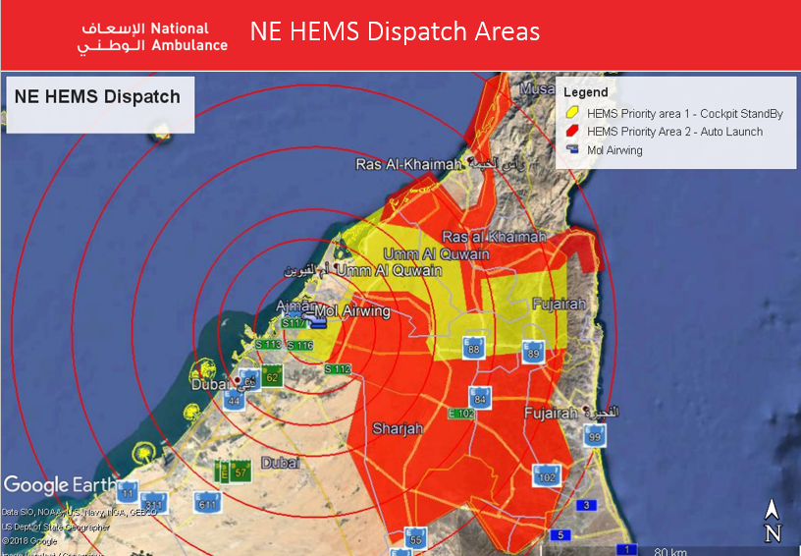

**Request Process for Auto launch and Cockpit Standby**

|  |
| --- |
| **CAD No. ­­­­­­­­__________________________________ details below to be recorded in CAD** |
| * **MVA in Auto launch or Cockpit Standby Zone** * MVA has “probable” significant MOI |
| * TL approves MOI AW Request for: * Cockpit Standby or, * Auto Launch |
| * MOI AW Ops contacted by SL on 06 598 9555   السلام وعليكم معاك _____________ من الإسعاف الوطني وردنا بلاغ من )عمليات الشرطة / الجمهور( عن حادث سير /تدهور بإصابات (عدد الإصابات لو وجدت) في شارع ______ في إمارة ______  نطلب منكم وضع طاقم الطائرة على الإستعداد cockpit standby وسنوافيكم بالمستجدات.(Standby)  نطلب منكم تفعيل الطائرة والإستجابة للبلاغ حسب الإحداثيات المرسلة لكم. (Launch)   * Confirm ETA and Name |
| * GPS coordinates to be sent from CAD to the following numbers   a 056 422 2825  b 050 252 4222 |
| * TL phones MOI AW Paramedic and activates on **050 514 8861** * General location * Pt Condition * No. Patients * Other Resources sent |
| * Shift Leader contact the Police Operations for the Emirate where the incident has occurred and tell them we are activating MOI Air wing into their Emirate. |
| * Shift Leader/senior call taker contacts the caller to gain more details if possible |
| * ACC TL sends SMS to MOI AW Paramedic Phone: **050 514 8861** * Send information as above |
| * MOI AW Paramedic updates ACC by SMS with expected Lift and ETA |
| * TL sends group SMS to ‘’Airwing” group in SMS |
| * HEMs Paramedic updates ACC on confirmed ETA |
| * TL updates Road Ambulance on Helicopter ETA |
| * MOI AW Paramedic give scene update when landed |
| * MOI AW Paramedic and ACC TL consult and decide destination Hospital |
| * ACC SL informs MOI AW Operations (06 598 9555) of destination Hospital |
| * MOI AW Paramedic give Pre-Alert info |
| * ACC TL - Pre-Alert Helicopter ETA to hospital |
| * ACC TL - Sends SMS to “Airwing” group regarding transporting of patient. |
| * ACC TL – Sends SMS to ‘’Airwing’’ group once mission is complete and airwing back at base. |